Packet Tracer - Comparing 2960 and 3560 Switches

1. Topology

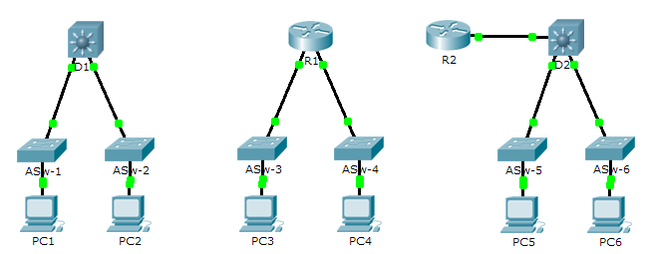

1. Objective

Part 1: Compare Layer 2 and Layer 3 Switches

Part 2: Compare a Layer 3 Switch and a Router

1. Background

In this activity, you will use various commands to examine three different switching topologies and compare the similarities and differences between the 2960 and 3560 switches. You will also compare the routing table of a 1941 router with a 3560 switch.

1. Compare Layer 2 and Layer 3 Switches
   * 1. Examine the physical aspects of **D1** and **ASw-1**.

* How many physical interfaces does each switch have in total? ______________
* How many Fast Ethernet and Gigabit Ethernet interfaces does each switch have?

________________________________________________________________________________

* List the transmission speed of the Fast Ethernet and Gigabit Ethernet interfaces on each switch.

________________________________________________________________________________

________________________________________________________________________________

* Are either of the two switches modular in design? ______________
  + 1. The interface of a 3560 switch can be configured as a Layer 3 interface by entering the **no switchport** command in interface configuration mode. This allows technicians to assign an IP address and subnet mask to the interface the same way it is configured on a router’s interface.
* What is the difference between a Layer 2 switch and a Layer 3 switch?

________________________________________________________________________________

________________________________________________________________________________

* What is the difference between a switch’s physical interface and the VLAN interface?

________________________________________________________________________________

________________________________________________________________________________

________________________________________________________________________________

* On which layer does a 2960 and 3560 operate?

________________________________________________________________________________

* Which command allows a technician to assign an IP address and subnet mask to the Fast Ethernet interface on a 2960?

________________________________________________________________________________

________________________________________________________________________________

* Issue the **show run** command to examine the configurations of the **D1** and **ASw-1** switches. Do you notice any differences between them?

________________________________________________________________________________

________________________________________________________________________________

* Display the routing table on both switches using the **show ip route** command. Why do you think the command does not work on **ASW-1**, but works on the **D1**?

________________________________________________________________________________

________________________________________________________________________________

________________________________________________________________________________

1. Compare a Layer 3 Switch and a Router
   * 1. Up until recently, switches and routers have been separate and distinct devices. The term switch was set aside for hardware based devices that function at Layer 2. Routers, on the other hand, are devices that make forwarding decisions based on Layer 3 information and use routing protocols to share routing information and to communicate with other routers. Layer 3 switches, such as the 3560, can be configured to forward Layer 3 packets. Entering the **ip routing** command in global configuration mode allows Layer 3 switches to be configured with routing protocols, thereby possessing some of the same capabilities as a router. However, although similar in some forms, they are different in many other aspects.

* Open the Physical tab on D1 and R1. Do you notice any similarities and differences between the two?

________________________________________________________________________________

________________________________________________________________________________

________________________________________________________________________________

________________________________________________________________________________

* Issue the **show run** command and examine the configurations of R1 and D1. What differences do you see between the two?

________________________________________________________________________________

________________________________________________________________________________

________________________________________________________________________________

* Which command allows D1 to configure an IP address on one of its physical interfaces?

________________________________________________________________________________

* Use the **show ip route** command on both devices. Do you see any similarities or differences between the two tables?

________________________________________________________________________________

________________________________________________________________________________

________________________________________________________________________________

* Now, analyze the routing table of R2 and D2. What is evident now that was not in the configuration of R1 and D1.

________________________________________________________________________________

* + 1. Verify that each topology has full connectivity be completing the following tests:
* Ping from **PC1** to **PC2**
* Ping from **PC3** to **PC4**
* Ping from **PC5** to **PC6**

In all three examples, each PC is on a different network. Which device is used to provide communication between networks?

____________________________________________________________________________________

Why were we able to ping across networks without there being a router?

____________________________________________________________________________________

____________________________________________________________________________________

____________________________________________________________________________________

____________________________________________________________________________________

1. Suggested Scoring Rubric

|  |  |  |  |
| --- | --- | --- | --- |
| Activity Section | Question Location | Possible Points | Earned Points |
| Part 1: Compare Layer 2 and Layer 3 Switches | a | 20 |  |
| b | 40 |  |
| **Part 1 Total** | | **60** |  |
| Part 2: Compare a Layer 3 Switch and a Router | a | 30 |  |
| b | 10 |  |
| **Part 2 Total** | | **40** |  |
| **Total Score** | | **100** |  |